# **Uni-polar**

## **NRZ(Non-Return to 0)**

* All signal levels are on one side of the time axis - either above or below.
* The signal level does not return to zero during a symbol transmission.
* Scheme is prone to baseline wandering and DC components. It has no synchronization or any error detection. It is simple but costly in power consumption.

## **RZ(Return to 0)**

# **Polar**

## **Polar-NRZ (Non-Return to 0)**

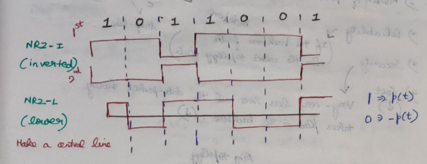

### **NRZ-I (Non-Return to 0-inverted)**

1 🡪 (invert)  
0 🡪 (don’t invert)

### **NRZ-L (Non-Return to 0-level)**

1 🡪 go up   
0 🡪 come-down

## **Polar-RZ**

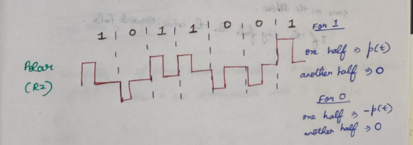

## **Manchester and Differential Manchester**

